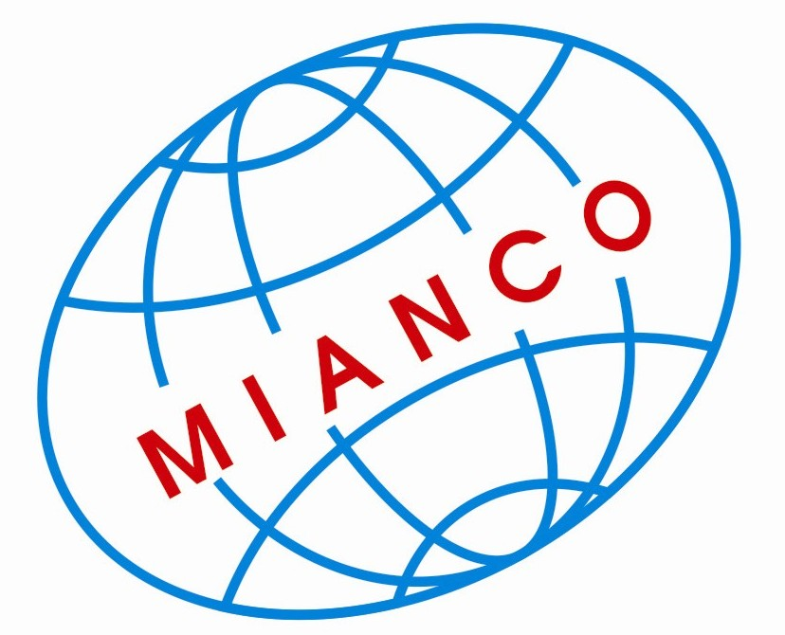
MINH ANH INTERNATIONAL CO., LTD
36 Tran Van Quang Str., Ward 10, Tan Binh Dist., HoChiMinh City, VN.
Tel.: 84 8 39770515 Fax.: 84 8 39770516
Email: a-t2002co@hcm.vnn.vn salesmianco@hcm.fpt.vn

Dear Sir/ Madam

Based on the information from VCCI, we know that your company is handling DRAGON FRUIT We would like to take this opportunity to send our company profile and product to refer.

With over 5 years experience in processing and exporting DRAGON FRUIT, we are proud to bring the best quality and the most reasonable price to our esteemed company. Our products are processed under the modern facilities that reach the standard of HACCP, ISO and EU Certificate. We can supply various specifications such as: color, size, style… to our current main markets in other country in the world.

+ Product: Dragon fruit
+ Color: white flesh and red skin White flesh and Red skinSkin: greenish yellow or light yellow, smooth on the surface and white spongy under the surface
+ Picture: 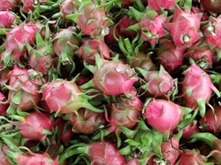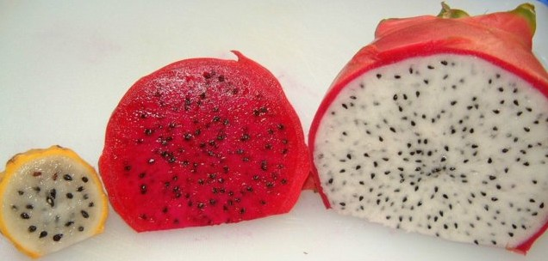

+ Net weight unit: 270gr to 1kg
+ Nutrition: Calories 1%; Protein: 2%; Vitamins: C, B6;
+ Foreign matter: < 1%
+ Packing: 10kg/carton box or depend on your request.
+ Min quantity: 1container 20feet
+ Payment: L/C, TT…

The specification is upon the customer’s requirement
The brand name or label as customer’s requirement

For further information of my company and any question for goods, please feel free to contact me. I appreciate your soonest reply and hope to have soonest co-operation with your esteemed company.

Thanks & regards
Ms Thi Nhan
Gmail: exportmianco@gmail.com
MSN: dothinhan@hotmail.com
Skype: nhanexport
Hand phone: 84 1287575670

MINH ANH INTERNATIONAL CO., LTD MINH ANH INTERNATIONAL CO., LTD MINH ANH INTERNAT

MINH ANH INTERNATIONAL CO., LTD MINH ANH INTERNATIONAL CO.,LTD MINH ANH INT

